**VISVESVARAYA TECHNOLOGICAL UNIVERSITY**

### Jnana Sangama, Santhibastawad Road, Machhe Belagavi - 590018, Karnataka, India



**A DBMS MINI Project Report**

**on**

**TRIP PACKAGES**

**Submitted in the partial fulfillment of the requirements for the V semester of the Degree of**

## BACHELOR OF ENGINEERING

### IN

**COMPUTER SCIENCE AND ENGINEERING**

**For the Academic Year 2019-2020**

**By**

**APEKSHA BHARADWAJ H(1CE17CS016)**

**DIKSHITA JAIN(1CE17CS032)**

**Under the guidance of**

**Mrs.ARCHANA BHAT**

**Asst.Professor,Dept.of CSE**



**CITY ENGINEERING COLLEGE**

#### Doddakallasandra, Kanakapura Road,

#### Bengaluru-560061

**CITY ENGINEERING COLLEGE**

#### Doddakallasandra, Kanakapura Road, Bengaluru-560061

**DEPARTMENT OF COMPUTER SCIENCE AND ENGINEERING**



**CERTIFICATE**

This is to certify that the DBMS Mini Project entitled **TRIP PACKAGES** carried out by, **APEKSHA BHARADWAJ H** with University seat number **1CE17CS016** and **DIKSHITA JAIN** with University seat number **1CE17CS032**, are bonafide students of City Engineering Collegein partial fulfilment for the award of **Bachelor of Engineering in COMPUTER SCIENCE** **AND** **ENGINEERING** of the VisvesvarayaTechnologicalUniversity, Belgaum during the year 2019-20. It is certified that all corrections / suggestions indicated for Internal Assessment have been incorporated in the report deposited in the departmental library. The Project report has been approved as it satisfies the academic requirements in respect of Database Management System with Mini Project Laboratory prescribed for the said Degree.

**Mrs.Archana Bhat Mr.B Vivekavardhana Reddy Dr.V.S Rama Murthy**

Asst. Prof, Dept. of CSE Head, Dept of CSE Principal

External Viva

Name of Examiners Signature with date

1.

2.

# ABSTRACT

Trip packages is a web based application developed and designed using PHP, HTML and CSS. This system has been developed to show how the data/information/packages is managed.

All data being used is stored in a MYSQL database. The system uses a server side scripting language, PHP to communicate with the stored database.

Customer is provided with a reservation page where the customer can sign up and login to choose the packages and make room or dining reservations. Once the reservation is completed, customer can download the receipt where the total cost will be calculated and displayed.

It also provides a contact us page where the customers can provide feedback and also to contact .

# ACKNOWLEDGEMENT

The satisfaction and euphoria that accompany the successful completion of any task would be incomplete without the mention of the people who made it possible. So with gratitude, we acknowledge all those whose guidance and encouragement crowned my effort with success.

While presenting this DBMS Mini Project on “**Smart Intelligent System for Women Safety”,** we feel that it is our duty to acknowledge the help rendered to us by various persons.

Firstly we thank God for showering his blessings on us. We are grateful to our institution City Engineering College for providing us a congenial atmosphere to carry out the project successfully.

We would like to express our heartfelt gratitude to **Dr. V S Ramamurthy,**

Principal, CEC, Bangalore, for extending his support**.**

We would also like to express our heartfelt gratitude to **Prof. Vivekavardhana Reddy**, HOD, Computer Science and Engineering whose guidance and support was truly invaluable**.**

We are very grateful to our guide, **Mrs. Archana Bhat**, Asst. Prof., Department of Computer Science, for her able guidance and valuable advice at every stage of our project which helped me in the successful completion of our project.

We would also have indebted to our Parent and Friends for their continued moral and material support throughout the course of project and helping me in finalize the presentation.

Our hearty thanks to all those have contributed bits, bytes and words to accomplish this Project.

**APEKSHA BHARADWAJ H (1CE17CS016)**

**DIKSHITA JAIN (1CE17CS032)**

**TABLE OF CONTENTS**

|  |  |  |
| --- | --- | --- |
| **1. INTRODUCTION** | | **1** |
| 1.1 Background | | 1 |
|  | 1.1.1 Purpose | 1 |
| 1.2 Introduction about the project | | 1 |
| **2. LITERATURE SURVEY** | | **2** |
| 2.1 Problem Statement | | 2 |
| 2.2 Objectives | | 2 |
| 2.3 System Specifications | | 3 |
|  | 2.3.1 Hardware Specification | 3 |
|  | 2.3.2 Software Specification | 3 |
| 2.4 Feasibility Study- Trip packages | | 3 |
|  | 2.4.1 Technical feasibility | 3 |
|  | 2.4.2 Behavioral feasibility | 4 |
|  | 2.4.3 Economical feasibility | 4 |
| **3. SYSTEM DESIGN** | | **5** |
| 3.1 | Description of ER Diagram | 5 |
| 3.2 Description of Relational Schema Diagram | | 6 |
| 3.3 Logical Design | | 7 |
| 3.4 Physical Design- Trip packages | | 8 |
| 3.5 Input Design- Trip packages | | 8 |
| 3.6 Output Design- Trip packages | | 9 |
| **4. IMPLEMENTATION** | | **10** |
| 4.1 | Front end and Back end used | 10 |
|  | 4.1.1Front end: HTML and CSS | 10 |
|  | 4.1.2 Back end: PHP and MYSQL | 10 |
| 4.2 | Discussion of code segments | 11 |
|  | 4.2.1 Code to establish connection with the database | 11 |

|  |  |  |
| --- | --- | --- |
| 4.3 | Table Description | 12 |
| 4.4 | Stored Procedure and triggers | 14 |
|  | 4.4.2 Stored Procedure | 14 |
|  | 4.4.3 Triggers | 14 |
| **5. RESULTS** | | **16** |
|  | 5.1 Snapshots of result | 16 |
| **6. CONCLUSION AND FUTURE ENHANCEMENTS** | | **21** |
|  | 6.1 Conclusion | 21 |
|  | 6.2 Future Enhancements | 21 |
| **7. REFERENCES** | | **22** |

**LIST OF FIGURES**

|  |  |  |
| --- | --- | --- |
| **Fig. No.** | **Descriptions** | **Page** |
| Fig. 3.1 | ER Diagram of Trip packages | 6 |
| Fig. 2.2 | Schema Diagram of Trip packages | 7 |
| Fig. 5.1 | Home Page | 16 |
| Fig. 5.2 | Signup and login Page | 16 |
| Fig. 5.3 | Reservation Page | 17 |
| Fig. 5.4 | Message displayed after making a reservation | 17 |
| Fig. 5.5 | Downloading the receipt | 18 |
| Fig. 5.6 | Facilities Page | 18 |
| Fig. 5.7 | Gallery Page | 19 |
| Fig. 5.8 | Contact us | 19 |
| Fig. 5.9 | Admin login Page | 20 |
| Fig. 5.10 | Message displayed after clicking on Admin  login button | 20 |

**Chapter 1**

* 1. **Background**
     1. **Purpose**

**INTRODUCTION**

Trip packages is a web based application which provides a user friendly and interactive system to choose a package and make room or dining reservations. This web application facilitates an easy way for customers to select a package, book rooms and makes dining reservations. Customers can check in by providing their details and book room accordingly or make a dining reservation. This Project is a fine thought to make the complex procedure of the Travel management system to an easy manner which is systematic, modular designed, selective menu based user display. The modular design and constructed system is very much user oriented in which user can easily understand the tools and can do edit of his own choice.

### Scope

Travel Management system can be accessed by a user who has an account. Anyone can create an account in the signup page. The user accounts are maintained in the MySQL database which also stores the history of the users previous bookings. This record can be accessed by the admin only. It also allows the admin to access current active bookings.

* 1. **Introduction about the project**

This web application can be adapted by any Travel agency to take their business to an online platform. It is aimed at choosing a trip package, making room and dining reservations easier. Customers here get a variety of choices of packages and book a room or make a dining reservation, they can also visit gallery to know more about the Little adventures website and its amazing facilities. After making reservations they can pay online and also download the receipt.

## Chapter 2

**LITERATURE SURVEY**

* 1. **Problem Statement**

The project entitled Trip packages is a web based system which facilitates online reservation of packages, accommodations and dining from anywhere in the world. If a person wants to book his package and accomodation he would want to know the availbility of hotels in the city he wants to visit, different amenities provided in each hotel, the rates of those rooms, the constraints of the hotel. He may achieve all this through travel agencies, the guides available, by making enquiries in person, by making enquiries through telephone. After being satisfied with the choice he has to confirm his reservation by paying the amount personally or through middle persons. This process is laborious and his choice is limited.

So we found the necessity of providing all the information and the facility to reserve his package and accommodation through the net so that maximum satisfaction is achieved by the customer with least effort. The solution we are providing to this is to design a website that contains information about various facilities, types of pacakges, types of rooms and their rates.

## Objectives

The objective of Tip packages project is to design software to manage the details of Packages, Rooms, Customers, Booking, and hotel Services. That is:-

* + - To create a database of the Packages.
    - To enable the customer to reserve his /her package and accommodation in a hotel anywhere in the world sitting at home through the internet.
    - View the reservation status and to download the receipt of the payment.
    - Admin can modify, delete and view all the records.
    - DBMS gives multiuser access.
    - Give good security to database.
    - Give full control to data.
    - Platform independent.
    - Keep and maintain proper backups.

## System Specifications

### Hardware Specification

Processor: Intel COREI5 8TH GEN System bus: 64 BITS

RAM: 8 GB of RAM

### Software Specification

OS: WINDOWS 10

Front End: HTML, CSS Back End: PHP, MYSQL

## Feasibility Study – TRIP PACKAGES

An important outcome of the preliminary investigation is the determination that the system requested is feasible. Feasibility study is carried out to select the best system that meets the performance requirements.

Feasibility study is both necessary and prudent to evaluate the feasibility of the project at the earliest possible time. It involves preliminary investigation of the project and examines whether the designed system will be useful to the organization. Months or years of effort, thousand for millions of money and untold professional embarrassment can be averted if an in-conceived system is recognized early in the definition phase.

The different types of feasibility are: Technical feasibility, Operational feasibility, Economical feasibility.

### Technical feasibility

Technical Feasibility deals with the hardware as well as software requirements. Technology is not a constraint to type system development. We have to find out whether the necessary technology, the proposed equipment have the capacity to hold the data,

which is used in the project, should be checked to carry out this technical feasibility. The technical feasibility issues usually raised during the feasibility stage of investigation includes these

* + - * The hardware required is Pentium based server.
      * The system can be expanded.

### Behavioural feasibility

This feasibility test asks if the system will work when it is developed and installed. Operational feasibility in this project:

* + - * The proposed system offers greater level of user-friendliness.
      * The proposed system produces best results and gives high performance. It can be implemented easily. So this project is operationally feasible.

### Economical feasibility

Economic Feasibility deals about the economic impact faced by the organization to implement a new system. Financial benefits must equal or exceed the costs. The cost of conducting a full system, including software and hardware cost for the class of application being considered should be evaluated. Economic Feasibility in this project:

* + - * The cost to conduct a full system investigation is possible.
      * There is no additional manpower requirement.
      * There is no additional cost involved in maintaining the proposed system.

## Chapter 3

**SYSTEM DESIGN**

* 1. **Description of ER Diagram**

An Entity-Relationship Diagram, usually referred to as an ER Diagram represents the attributes, entities and relationship in a relational schema diagram.

* + - Entities like Signup, Admin and Dining are represented using rectangular boxes in the ER Diagram.
    - The attributes which characterize the entities are represented in ovals, each attached to the entity type using a straight line. The attribute which is designed as the primary key is identified by underlining it within the oval.
    - Relationships like views, manages and gives are represented in diamond boxes which are attached to the entity types participating in the relationship using straight lines.
    - The total participation of the entities participating in a relationship is identified by two straight lines from the entity type to the diamond. Whereas, the partial participation is identified by a single line.
    - The cardinality ratios are as follows:

1. Signup: Dining is of the cardinality 1: n as each customer may reserve a table for dining n number of times.
2. Signup: Reservation is of the cardinality 1: n as each customer may reserve a room n number of times.
3. Signup: Feedback is of the cardinality 1: n as each customer can give n number of feedbacks.
4. Reservation: roompayment is of the cardinality 1: 1 as each reservation is associated with a corresponding room payment as vice versa.
5. Dining: diningpayment is of the cardinality 1: 1 as each dining is associated with a corresponding dining payment as vice versa.
6. Admin: Reservation is of the cardinality 1: n as each admin manages n number of room reservations made by customers.
7. Admin: Dining is of the cardinality 1: n as each admin manages n number of dining reservations made by customers.
8. Admin: Feedback is of the cardinality 1: n as each admin can view number of feedbacks given by the customers.

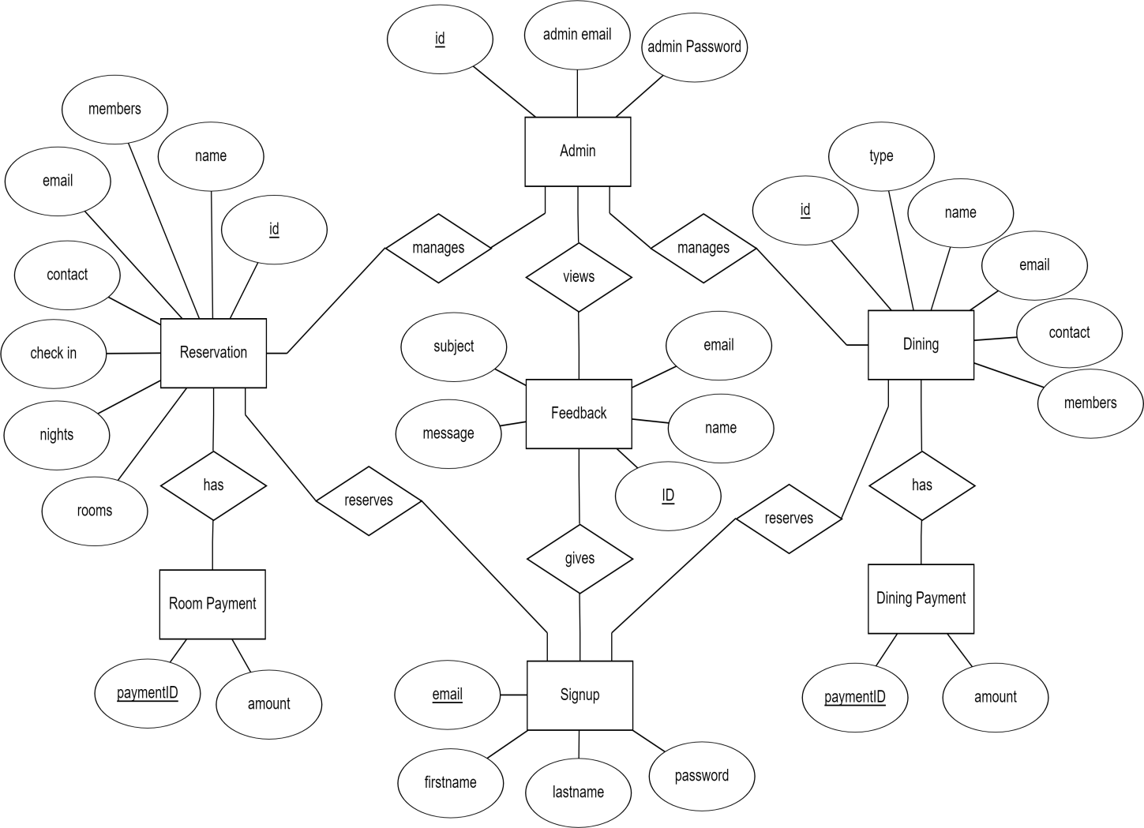

1

1

1

n

n

n

1

1

n

n

n

1

1

1

1

1

Fig 3.1 Shows the ER Diagram of Trip Packages with relationships and cardinality ratios.

Fig 3.1: ER Diagram of Trip Packages

## Description of Relational Schema Diagram

The term database Schema refers to the description of the database that includes the database structure and various constraints on the database. The Schema diagram is in turn an illustrative display of the database schema. The primary keys are underlined and the referential integrity constraints are depicted by arrows pointing to the keys they reference.

Figure 3.2 shows the Relational Schema Diagram along with primary keys and referential integrity constraints.



Message

Subject

Email

Name

ID

Signup

|  |  |  |  |
| --- | --- | --- | --- |
| Email | Firstname | Lastname | Password |

Dining

|  |  |  |  |  |  |  |  |  |
| --- | --- | --- | --- | --- | --- | --- | --- | --- |
| id Name Email Contact Type Data Members  PaymentID Amount | | | | | | | | |
|  | | |  | | | | | |
| id | Name | Email | | Contact | Members | Checkin | Nights | Rooms |

|  |  |  |  |  |  |  |
| --- | --- | --- | --- | --- | --- | --- |
|  |  |  |  |  |  |  |
|  |  |  |  |  |  |  |

DiningPayment

|  |  |
| --- | --- |
|  |  |

Reservation

RoomPayment

|  |  |
| --- | --- |
| PaymentID | Amount |

Feedback

Admin

|  |  |  |  |
| --- | --- | --- | --- |
| Email | Firstname | Lastname | Password |

Fig 3.2: Schema Diagram of Hotel Management System

## Logical Design

The logical flow of a system and define the boundaries of a system. It includes the following steps:

* + - Reviews the current physical system – its data flows, file content, volumes, frequencies etc.
    - Prepares output specifications – that is, determines the format, content and Frequency of reports.
    - Prepares input specifications – format, content and most of the input functions.
    - Prepares edit, security and control specifications.
    - Specifies the implementation plan.
    - Prepares a logical design walk through of the information flow, output, input, controls and implementation plan.
    - Reviews benefits, costs, target dates and system constraints.

## Physical Design- Trip Packages

Physical system produces the working systems by defining the design specifications that tell the programmers exactly what the candidate system must do. It includes the following steps:

* + - Design the physical system.
    - Specify input and output media.
    - Design the database and specify backup procedures.
    - Design physical information flow through the system and a physical design Walk through.
    - Plan system implementation.
    - Prepare a conversion schedule and target date.
    - Determine training procedures, courses and timetable.
    - Devise a test and implementation plan and specify any new hardware/software.
    - Update benefits, costs, and conversion date and system constraints.

## Input Design- Trip Packages

Input Design deals with what data should be given as input, how the data should be arranged or code, the dialog to guide the operating personnel in providing input, methods for preparing input validations and steps to follow when error occur. Input Design is the process of converting a user-oriented description of the input into a computer-based system. This design is important to avoid errors in the data input process and show the correct direction to the management for getting correct information from the computerized system. It is achieved by creating user-friendly screens for the data entry to handle large volume of data. The goal of designing input is to make data entry easier and

to be free from errors. The data entry screen is designed in such a way that all the data manipulates can be performed. It also provides record viewing facilities.

When the data is entered it will check for its validity. Data can be entered with the help of screens. Appropriate messages are provided as when needed so that the user will not be in maize of instant. Thus the objective of input design is to create an input layout that is easy to follow.

## Output Design- Trip Packages

A quality output is one, which meets the requirements of the end user and presents the information clearly. The objective of output design is to convey information about past activities, current status or projections of the future, signal important events, opportunities, problems, or warnings, trigger an action, confirm an action etc. Efficient, intelligible output design should improve the system’s relationship with the user and helps in decisions making. In output design the emphasis is on displaying the output on a CRT screen in a predefined format. The primary consideration in design of output is the information requirement and objectives of the end users. The major formation of the output is to convey the information and so its layout and design need a careful consideration.

## Chapter 4

**IMPLEMENTATION**

* 1. **Front end and back end used**

### Front end: HTML and CSS

HTML is used as the front end tool to design web pages because:

* + - * It is easy to write, use and understand.
      * HTML also allows the use of templates, which makes designing a webpage easy.
      * All browsers support HTML.

CSS is used along with html to design the web pages as it is relatively easy to learn and produces better and cleaner code than applying all the styles directly to the HTML code. Also the following reasons make CSS for helpful:

* + - * Easy to maintain and update.
      * Greater consistency in design and formatting options.
      * Greater accessibility.

### Back end: PHP and MySQL

MySQL is a free-to-use, open-source database that facilitates effective management of databases by connecting them to the software. It is a stable, reliable and powerful solution with advanced features like the following:

* + - * MySQL is globally renowned for being the most secured and reliable DBMS used in popular web applications.
      * MySQL features a distinct storage-engine framework that facilitates system administrators to configure the MySQL database server for a flawless performance.
      * MySQL tops the list of robust transactional database engines available on the market with features like complete atomic, consistent, isolated, transaction support.

PHP (Hypertext Pre-Processor) is a server-side web programming language that is widely used for web development. MySQL is used with PHP as the back end tool in our web application.

* + - * PHP also has powerful output buffering that further increases over the output flow.
      * PHP is dynamic. PHP works in combination of HTML to display dynamic elements on the webpage.
      * PHP can be used with a large number of relational database management systems and runs on all of the most popular web servers and is available for many different operating systems.

## Discussion of Code Segment

### Code to establish connection with the database

<?php session_start();

$db=mysqli_connect('localhost','root','','trip') or die('could not connect');

?>

The above code establishes connection with the database by taking into account the username and password for the MySQL account and also the name of the database it is trying to establish the connection with. ‘$db’ is the variable used to establish the connection. The function used is ‘mysqli_connect()’.

## Table Description

1. Signup

|  |  |  |  |  |
| --- | --- | --- | --- | --- |
| **Field** | **Type** | **Null** | **Key** | **Extra** |
| email | varchar(255) | NO | PRI |  |
| firstname | varchar(255) | NO |  |  |
| lastname | varchar(255) | NO |  |  |
| password | varchar(255) | NO |  |  |

The above table stores the personal information concerning each registered user and their passwords.

1. Dining

|  |  |  |  |  |
| --- | --- | --- | --- | --- |
| **Field** | **Type** | **Null** | **Key** | **Extra** |
| id | int(255) | NO | PRI | AUTO_INCREMENT |
| name | varchar(255) | NO |  |  |
| email | varchar(255) | NO |  |  |
| contact | varchar(255) | NO |  |  |
| type | varchar(255) | NO |  |  |
| date | varchar(255) | NO |  |  |
| members | int(255) | NO |  |  |

The above table stores the details of each dining reservation made by a customer.

1. DiningPayment

|  |  |  |  |  |
| --- | --- | --- | --- | --- |
| **Field** | **Type** | **Null** | **Key** | **Extra** |
| paymentID | int(255) | NO | PRI | AUTO_INCREMENT |
| amount | int(255) | NO |  |  |

The above table stores the payment information for every corresponding dining reservation made.

1. Reservation

|  |  |  |  |  |
| --- | --- | --- | --- | --- |
| **Field** | **Type** | **Null** | **Key** | **Extra** |
| id | int(255) | NO | PRI | AUTO_INCREMENT |
| name | varchar(255) | NO |  |  |
| email | varchar(255) | NO |  |  |
| contact | varchar(255) | NO |  |  |
| members | int(255) | NO |  |  |
| checkin | varchar(255) | NO |  |  |
| package | varchar(255) | NO |  |  |

The above table stores the details of each room reservation made by a customer.

1. RoomPayment

|  |  |  |  |  |
| --- | --- | --- | --- | --- |
| **Field** | **Type** | **Null** | **Key** | **Extra** |
| paymentID | int(255) | NO | PRI | AUTO_INCREMENT |
| amount | int(255) | NO |  |  |

The above table stores the payment information for every corresponding room reservation made.

1. Feedback

|  |  |  |  |  |
| --- | --- | --- | --- | --- |
| **Field** | **Type** | **Null** | **Key** | **Extra** |
| ID | int(255) | NO | PRI | AUTO_INCREMENT |
| name | varchar(255) | NO |  |  |
| email | varchar(255) | NO |  |  |
| subject | varchar(255) | NO |  |  |
| message | varchar(255) | NO |  |  |

The above table stores all the feedbacks given by the customers. The Primary Key is a unique Feedback ID for each feedback

1. Admin

|  |  |  |  |  |
| --- | --- | --- | --- | --- |
| **Field** | **Type** | **Null** | **Key** | **Extra** |
| id | int(255) | NO | PRI | AUTO_INCREMENT |
| AdminEmail | varchar(255) | NO |  |  |
| AdminPassword | varchar(255) | NO |  |  |

The above stores the login details of each Administrator of the Hotel Management System. The Primary Key is id of the Administrator.

## Stored Procedure and Triggers

### Stored Procedure

A Stored Procedure is a set of SQL statements with an assigned name, which are stored in a relational database management system as a group, so it can be reused and shared by multiple programs.

CREATE PROCEDURE ‘fetch’ ()

NOT DETERMINISTIC NO SQL SQL SECURITY DEFINER

SELECT * from reservation, roompayment where reservation.id=roompayment.paymentID

The above stored procedure in Trip Packages will fetch the amount from roompayment table and other corresponding booking details from reservation table and then display as a combined result of the two.

### Triggers

A database trigger is procedural code that is automatically executed in response to certain events on a particular table or view in a database.

#### Trigger 1: dining_pay_update

CREATE DEFINER= ‘root’@’localhost’ TRIGGER ‘dining_pay_update’

AFTER INSERT ON ‘dining’ FOR EACH ROW

INSERT INTO diningpayment(paymentID,amount) VALUES (new.id, 500*(new.members))

The above trigger used in the application will perform its operation every time an insertion operation takes place in ‘dining’ table. This trigger will insert the computed amount into the diningpayment table.

## Chapter 5

**RESULTS**

**5.1 Snapshots of result**

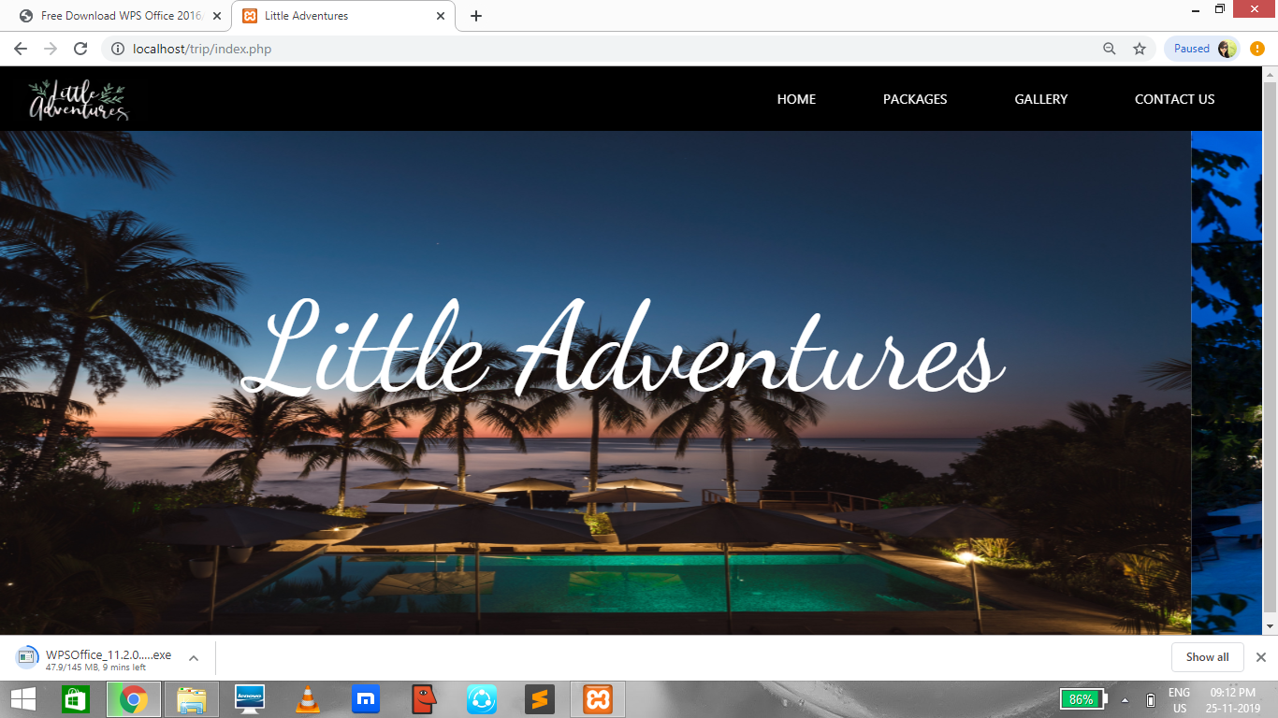

Fig 5.1 Home Page

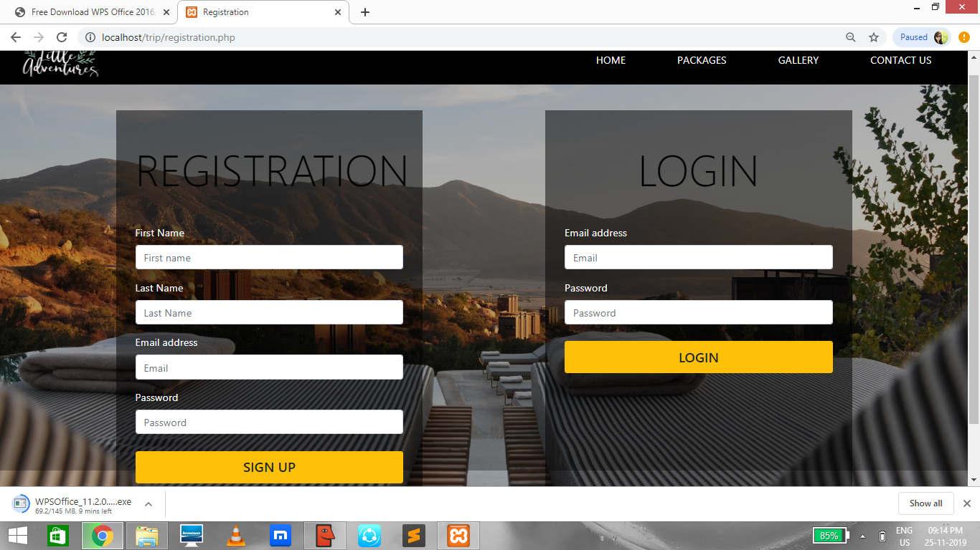

Fig 5.2 Signup and login Page

New users can sign up for a new account by filling the details in registration form and use the details to login into their account. In login form the page validates the details with the stored data in the database and let the user login only if the details are correct.

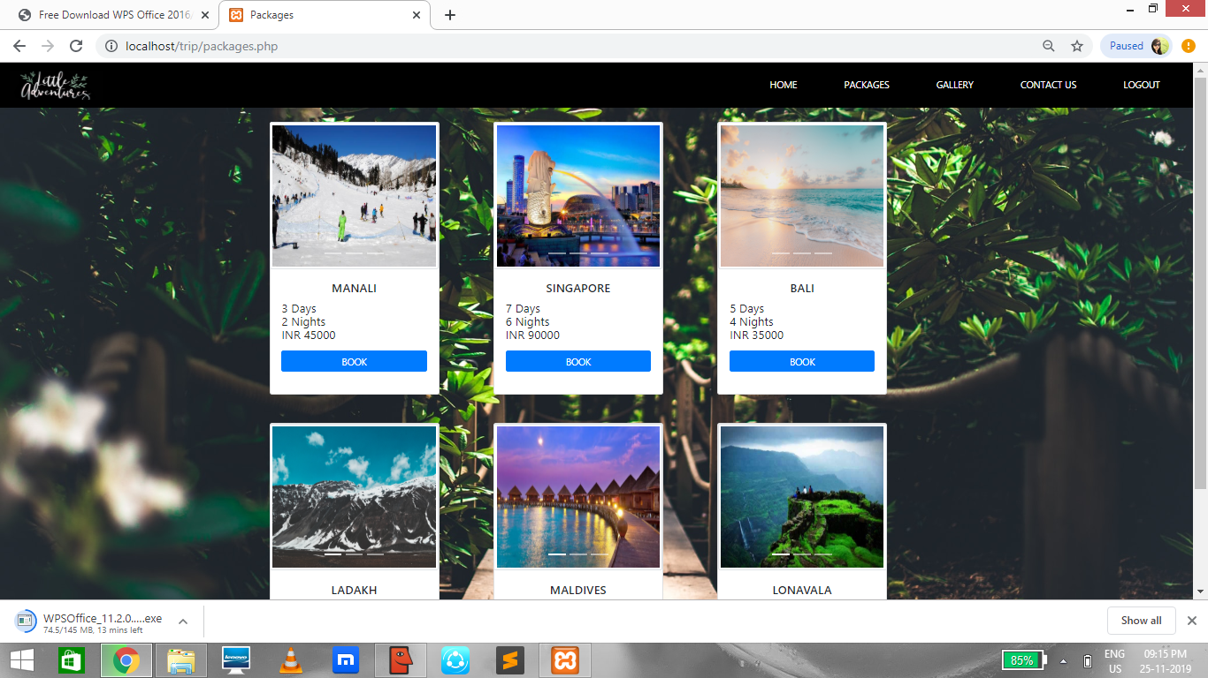

Fig 5.3 Packages Page

In this page users can select their desired package.

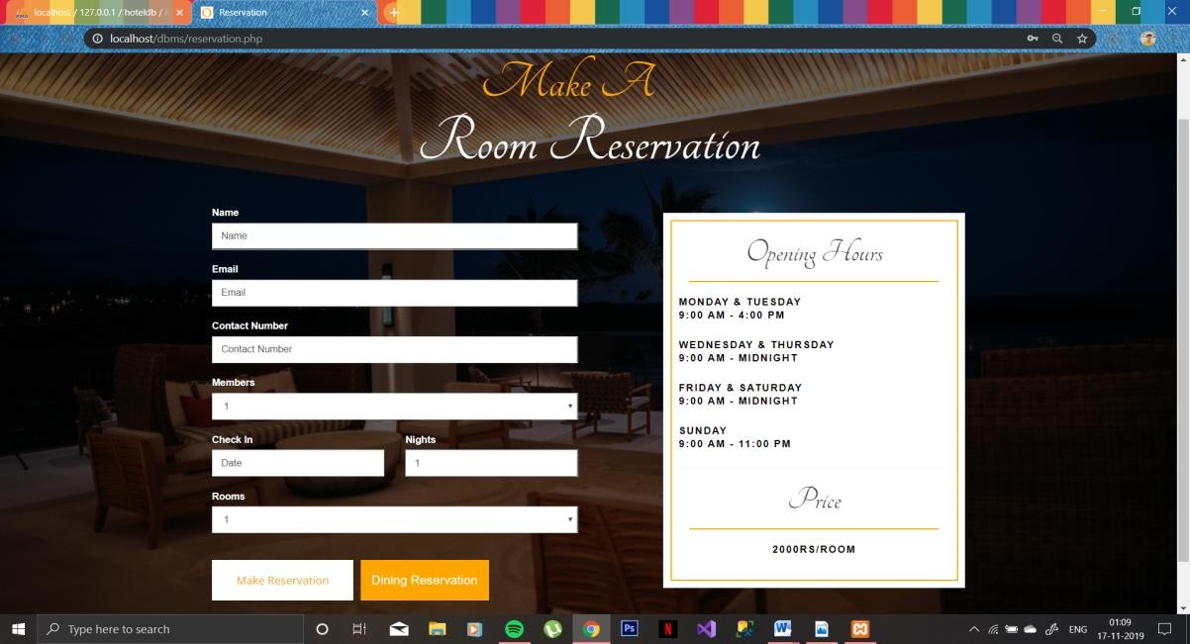

Fig 5.4 Reservation Page

After choosing the package, Users can make rooms reservation and dining reservation.

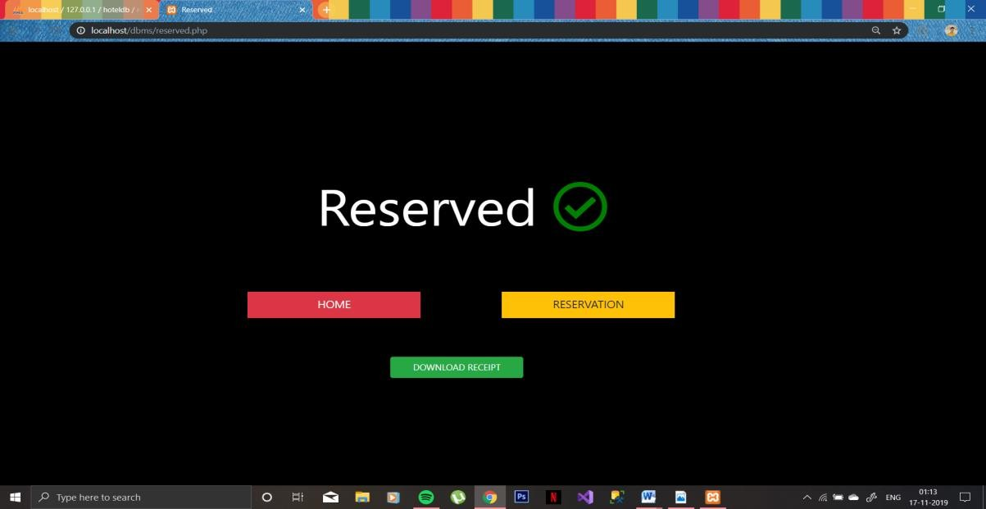

Fig 5.5 Message displayed after making a reservation

After making a room or dining reservation, user is directed to a new page where it displays a message which says ‘reserved’. After that users have options to go back to home page or make another reservation and also to download the receipt.

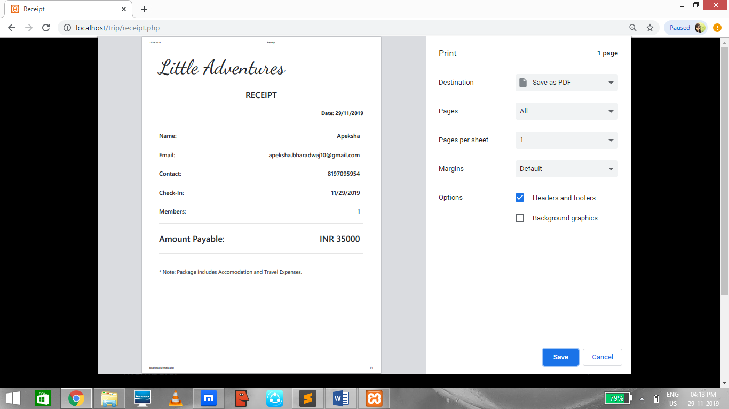

Fig 5.6 Downloading the receipt

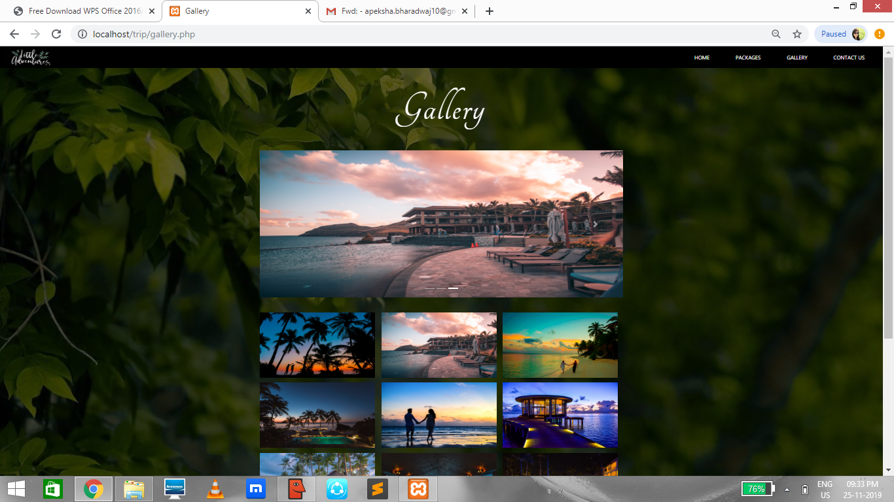

Fig 5.7 Gallery Page

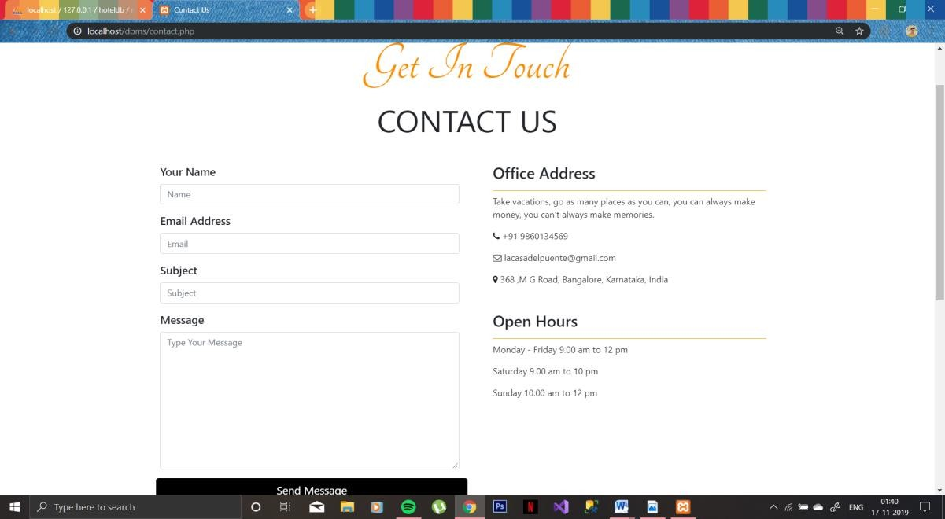

Fig 5.8 Contact us

Users can give their valuable feedback about the hotel in contact us page and can also get to know the timings and location of the hotel.

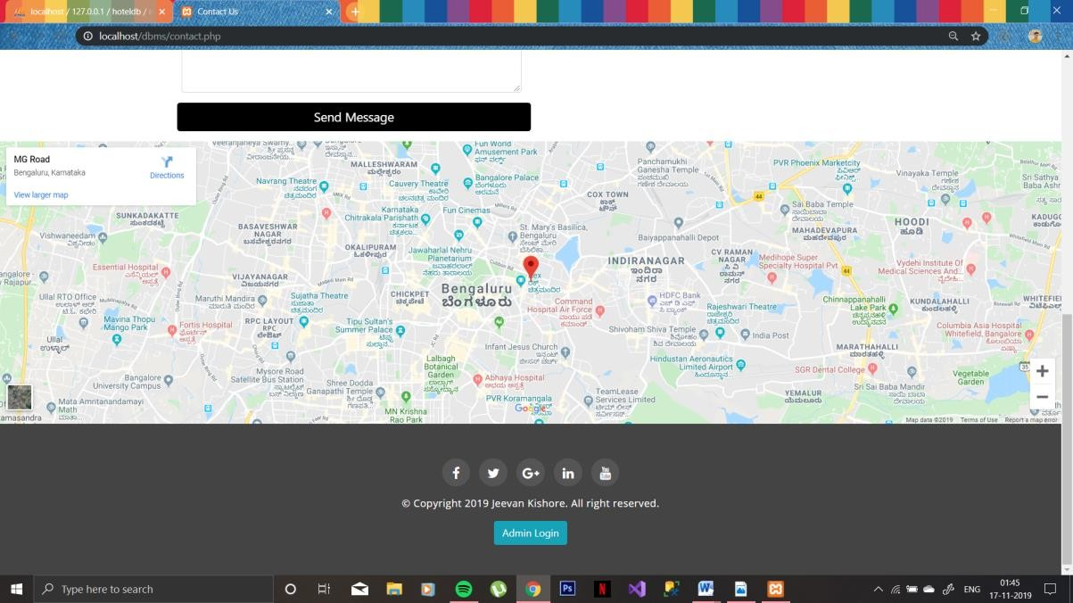

Fig 5.9 Admin login Page

There is an admin login button in contact us page in which admin can login and can view, modify and delete the database records.

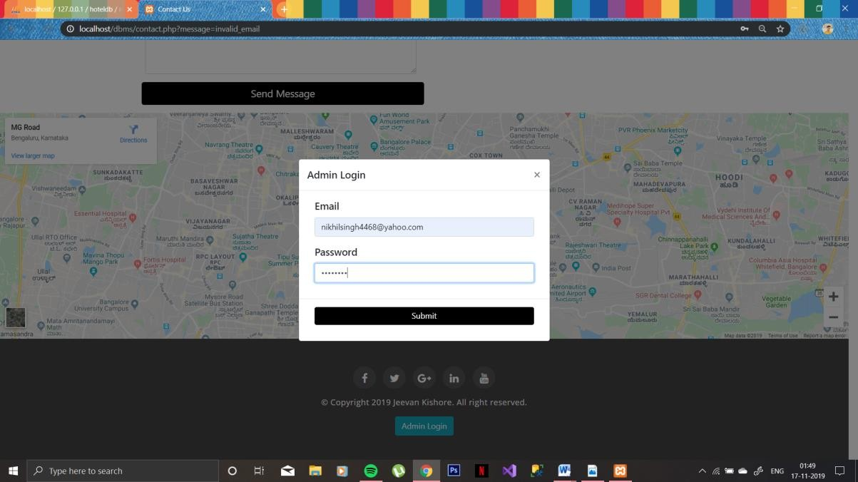

Fig 5.10 Message displayed after clicking on Admin login button

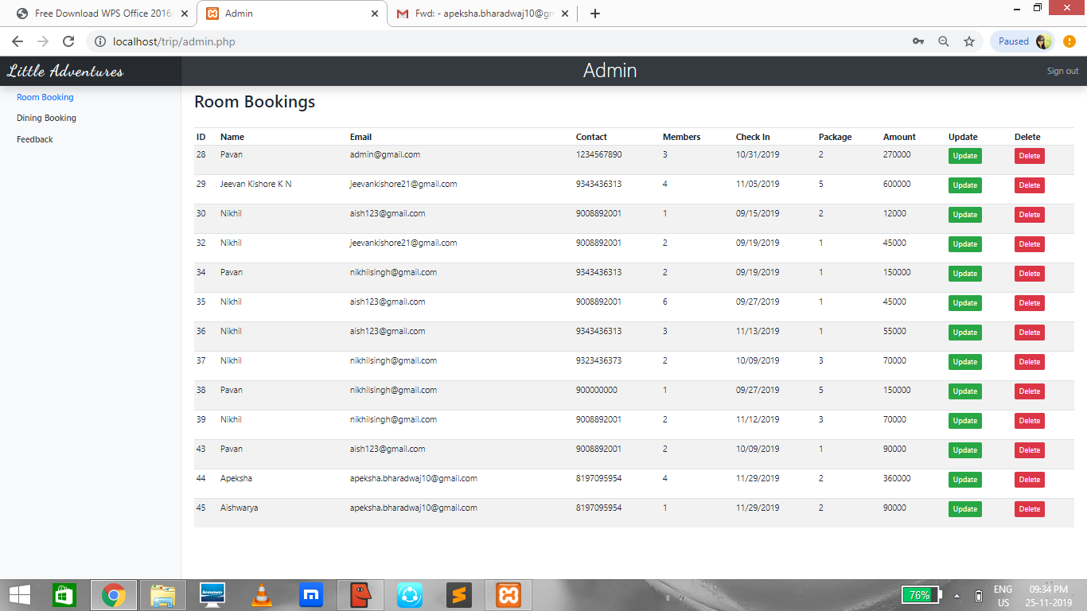

Fig 5.11 Admin page

## Chapter 6

**CONCLUSION AND FUTURE ENHANCEMENTS**

* 1. **Conclusion**

The primary goal of Trip Packages is that it permits the customers globally to reserve a package and make room or dining reservation in the hotel at any time. It will provide a unique booking functionality for the customers anywhere in the world. The objective of this project is to simplify the day to day processes of the Travel Agency. The system will be able to handle many services to take care of all customers in a quick manner. The user interface must be simple and easy to understand even by the common man. Customers can give the feedback to the hotel based on how the service was and also can contact the hotel for more queries. The admin here has the right to modify or delete the data of customers which are stored in database.

## Future enhancements

The application can be enhanced by many extra features. Some of these features can be summarized as follow:

* + - Develop an iOS and android application for this website.
    - To allow payment through various other payment gateways like Paytm, Gpay, PhonePe, etc.
    - Improving the user interface, because the user interface can always be improved.

## Chapter 7

**TEXT BOOK**

**REFERENCES**

1. Raghu Ramakrishnan and Johannes Gehrke, Database Management Systems, McGRAW HILL, 3rd Edition.
2. Ramez Elmasri and Shamkant B. Navathe, Fundamentals of Database Systems, Pearson, 7th Edition.

## WEBSITED REFERRED

1. [www.geeksforgeeks.com](http://www.geeksforgeeks.com/)
2. [www.Stackoverflow.com](http://www.Stackoverflow.com/)
3. [www.W3schools.com](http://www.W3schools.com/)

# DECLARATION

We student of 5th semester BE, Computer Science and Engineering College hereby declare that project work entitled for “Trip Packages” has been carried out by us at City Engineering college, Bengaluru and submitted in partial fulfillment of the course requirement for the award of the degree of **Bachelor of Engineering in Computer Science and Engineering of Visvesvaraya Technological University, Belgaum,** during the academic year 2019-2020.

We also declare that, to the best of our knowledge and belief, the work reported here does not from the part of dissertation on the basis of which a degree or award was cnferred on a earlier occasion on this by any other student.

Date:

Place: Bangalore

APEKSHA BHARADWAJ H DIKSHITA JAIN

(1CE17CS016) (1CE17CS032)